**Purpose** - This document describes the fabrication of the Smart Charger enclosure. It outlines machining and assembly.

**Scope** - This document covers the COSMiiC Smart Charger CLBC Rev A 231207 PCB assembly dated 2024-Jul-25.

**Referenced Documents**

- Smart Charger Enclosure BOM 250201.xlsx

- <https://www.pactecenclosures.com/wp-content/uploads/2024/03/drw_LH64-130.pdf>

- CLBC Rev A Cables 250115.sch

**Definitions and Terminology**

- SC - Smart Charger

- PacTec - Electronic Enclosure Manufacturer

- CLBC Rev A Cables 250115.sch

**Introduction** - The Smart Charger (SC) is used to charge the batteries in the implanted Power Module (PM) through an inductive link. The SC enclosure houses the electronics. The SC enclosure uses an off the shelf PacTec enclosure LH64-130 with custom 3D printed panels. This document presents the bill of materials (BOM), enclosure mods/fabrication, and assembly instructions for the SC enclosure.

**Bill of Material** - The BOM (Smart Charger Enclosure BOM 250201.xlsx) for the SC is presented below. The Excel file includes links to the parts.

Table 1. Smart Charger Bill of Materials.



**Fabrication** - The SC enclosure requires machine work for display clearance and mounting of the pushbuttons.

*Display Clearance Machining* - The inside lip on the enclosure panel groove needs to be removed on the top and the bottom enclosure halves for clearance of the display. The two halves of the enclosure are keyed to each other. Pay attention to the orientation with respect to the keying groove and ridges as illustrated in the detailed photos presented below. A positioning fixture is used for marking the enclosure panel groove lips for removal, as well as drilling the enclosure for the push buttons.



Figure 1. Photo of the Enclosure Bottom with the Positioning Jig for

Removing the Inside Panel Groove Lip.

Use an Exacto knife to mark the inside panel groove lip removal edges. The panel groove lip is removed with an 1/8” end mill. A drill press with a fence was used to remove the lip as shown in Figure 2.

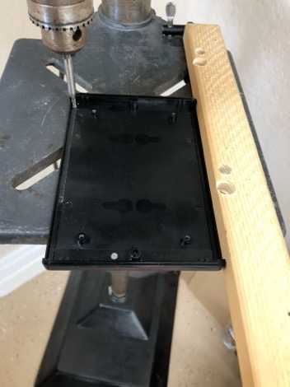

Figure 2. Photo of Removing the Inside Panel Groove Lip from the Enclosure Bottom

on a Drill Press with a 1/8” End Mill.

Details of the enclosure bottom panel grove lip removed is presented in Figure 3. The removed lip is flush with the enclosure bottom. Note the position of the ridge and groove keying.



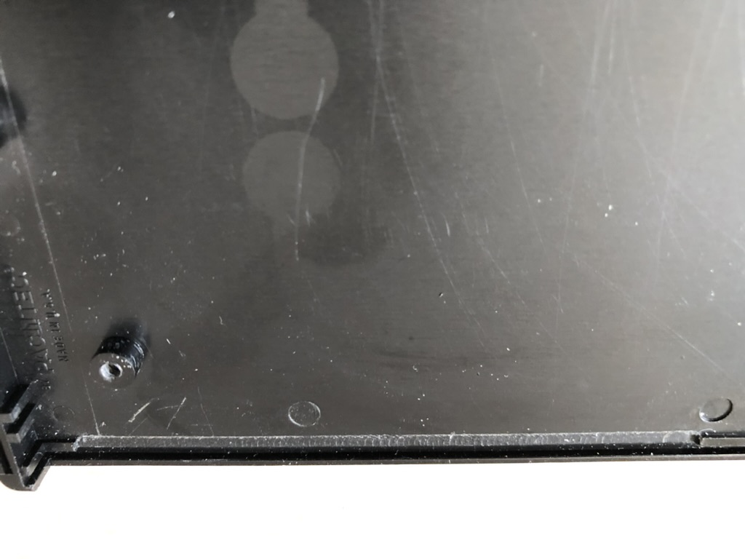

Figure 3. Photo of the Enclosure Bottom with

the Inside Panel Groove Lip Removed.

The same milling procedure is used to remove the inside panel groove lip from the top of the enclosure. Mark the lip with an Exacto knife. Again, pay attention to the ridge and groove orientation to assure the removed lips are on the same face of the assembled enclosure as shown in Figure 4.



Figure 4. Photo of the Enclosure Top with the Positioning Jig for

Removing the Inside Panel Groove Lip.

Drilling the holes for the push buttons uses the same positioning fixture for locating the holes as shown in Figure 5. Tape the fixture in place to avoid it moving during the drilling process. Use a # 58 drill. Drill one of the right position switch holes and put a wire through it to further stabilize the positioning fixture. A pin vise works good for drilling the holes.



Figure 5. Photo of the Enclosure Top with the Positioning Jig for the Push Button Drilling.

Position the push buttons as illustrated in Figure 6. Pay attention to the orientation of the piano key rocker direction and snug the buttons tight to the enclosure surface.

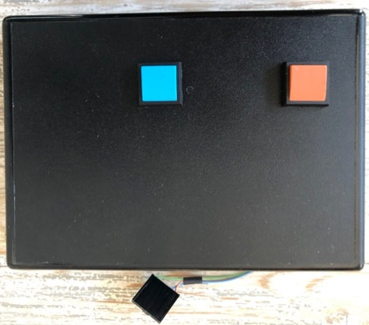

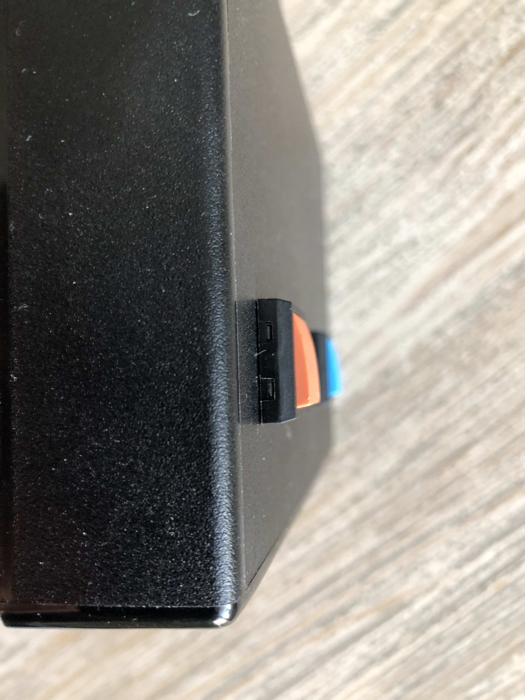

Figure 6. Photo of the Enclosure Top with the Push Buttons and Connector.

Flip the enclosure over and double check the fit to the enclose face. Shoulder pieces of bare wire across the switch terminals as shown in Figure 7. Clipped off resistor leads, or bare bus wire works good.

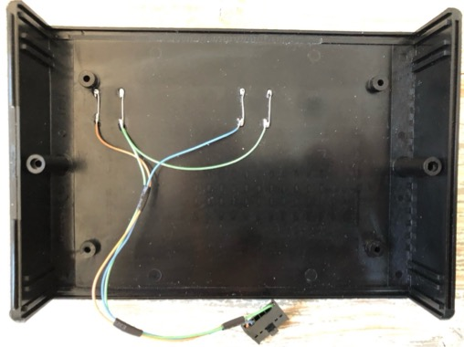

Figure 7. Photo of the Enclosure Top with the Push Buttons Wired with the Connector.

Refer to the cable schematic, CLBC Rev A Cables 250115.sch, for wire color and length details. The fabricated enclosure top assembly should look like that presented in Figure 7 above. Note the keying ridges (left) and groove (right).

**Enclosure Cabling** - Various cables are used to connect the motherboard to connectors, push buttons, display, and the antenna on the enclosure. The push button cabling is described above. There is the display cable, the coil cable, and antenna cable for the enclosure as well. Refer to CLBC Rev A Cables 250115.sch for electrical details of the push buttons, display and coil cables.

*Display Cable* – A pigtail cable connects the enclosure character display to the SC motherboard. Photos of the display cable are presented in Figure 8. The Smart Coil and Passive Coil cables are shown in Figure 9.

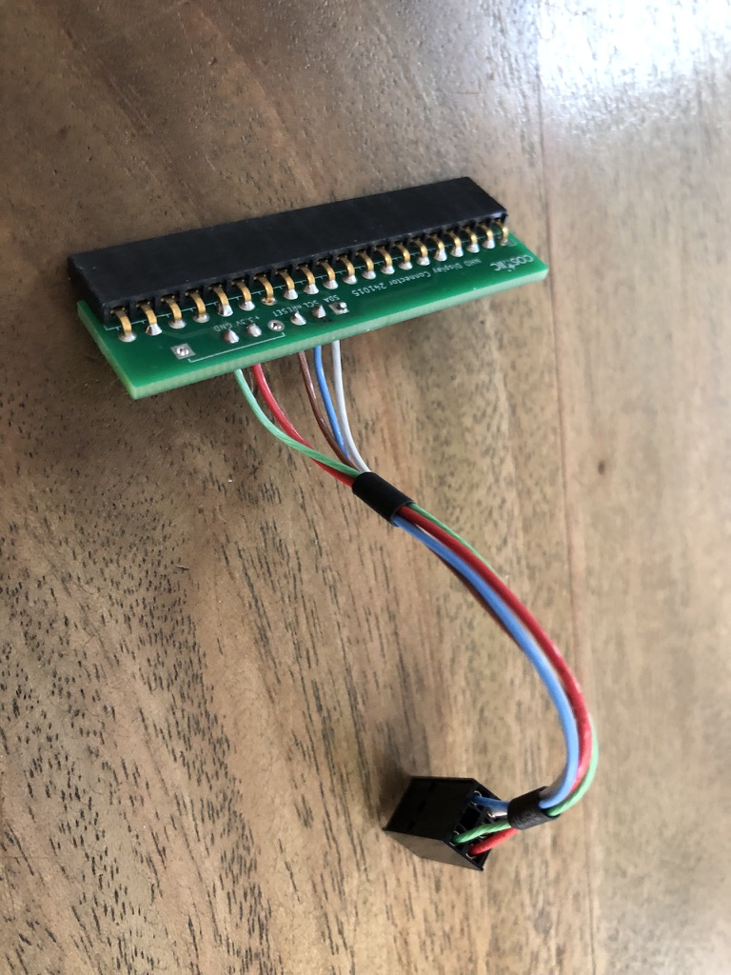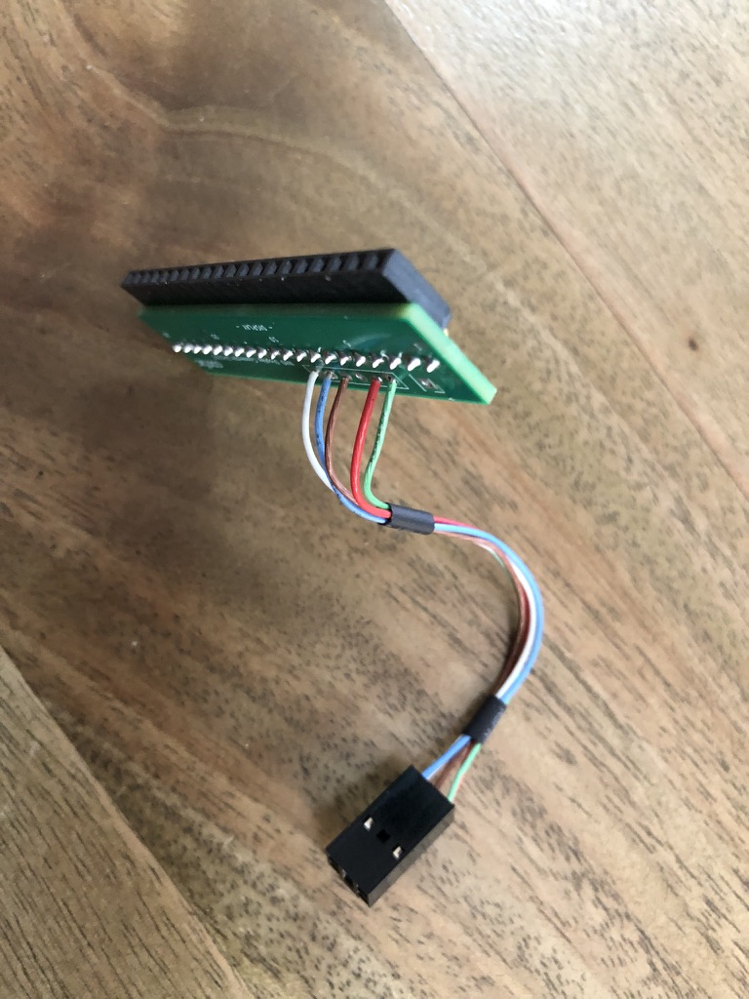

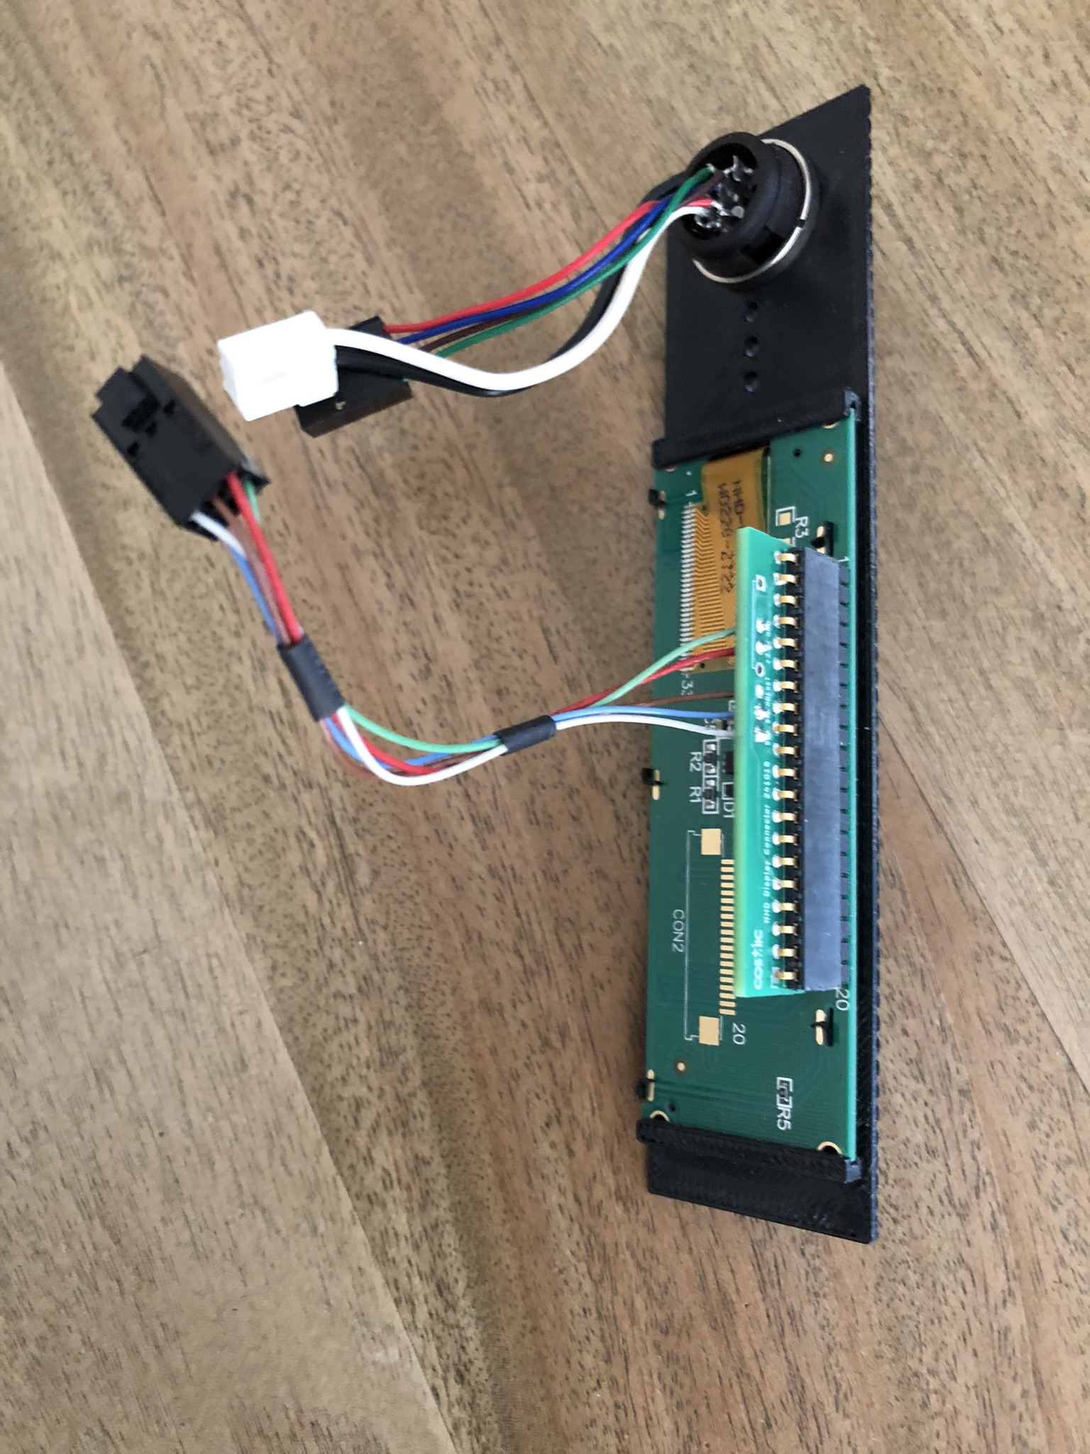

Figure 8. Enclosure Character Display Cable.

Refer to CLBC Rev A Cables 250115.sch for the appropriate schematic and details of the display cable. It consists of a PCB, a 20-pin right angle connector, and a wired pigtail. There is also a mating connector that needs to be soldered to the display, Item 10 on the BOM.

*Coil Cable* – The motherboard is connected to the enclosure coil connector via a cable. The system can accommodate either a Passive Coil or a Smart Coil. The Coil cables are shown in Figure 9.

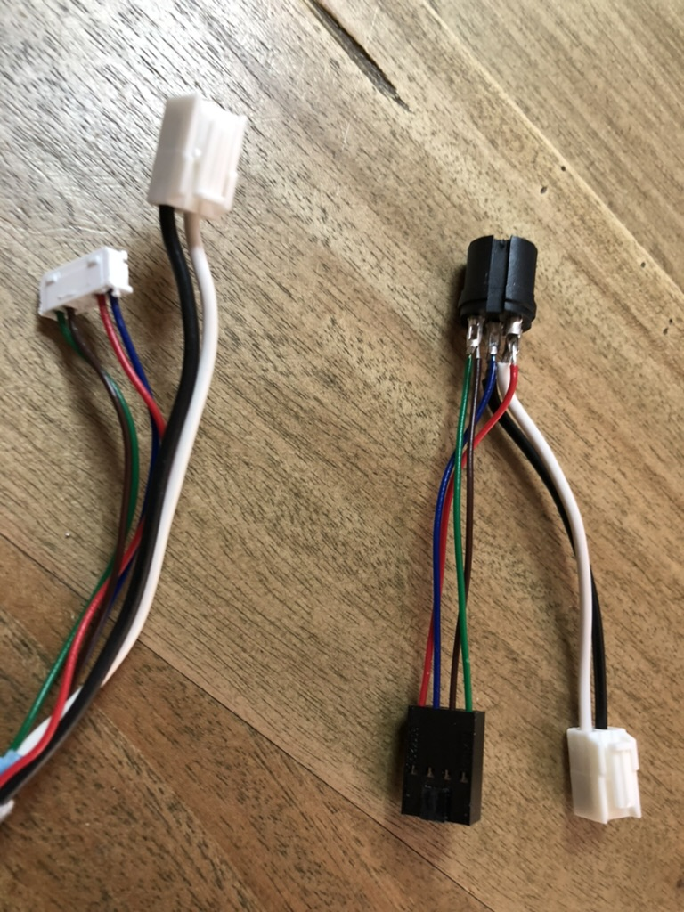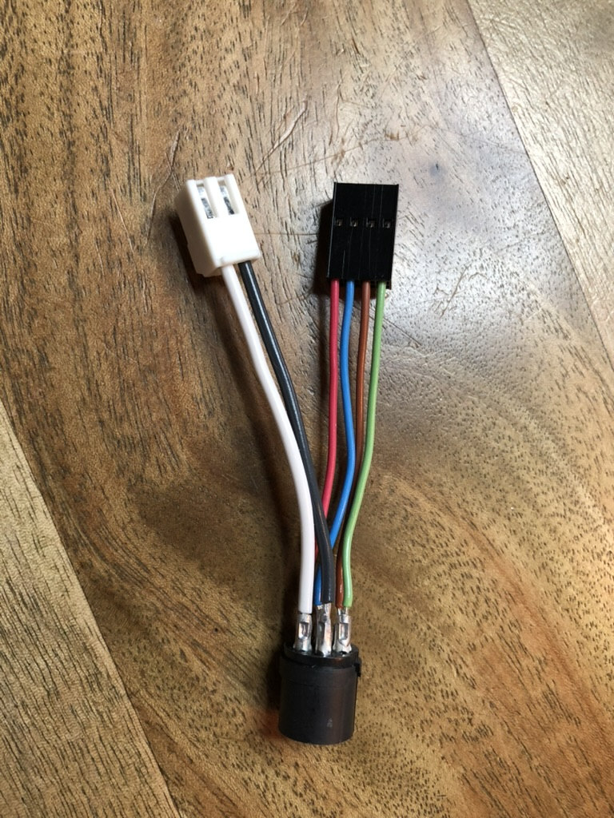

Figure 9. Coil Enclosure Connector Cables (Left Smart Coil, Right Passive Coil).

Refer to CLBC Rev A Cables 250115.sch for the appropriate schematic and details of the selected coil cable. A Molex 638258100 crimp tool is used for the black connector contacts. An Iwiss IWS-2412M is used for the white connector contacts. The 2.2 slot is used for the de-insulated wire and the 2.5 slot crimp is used for the insulated part. Refer to the figure below.

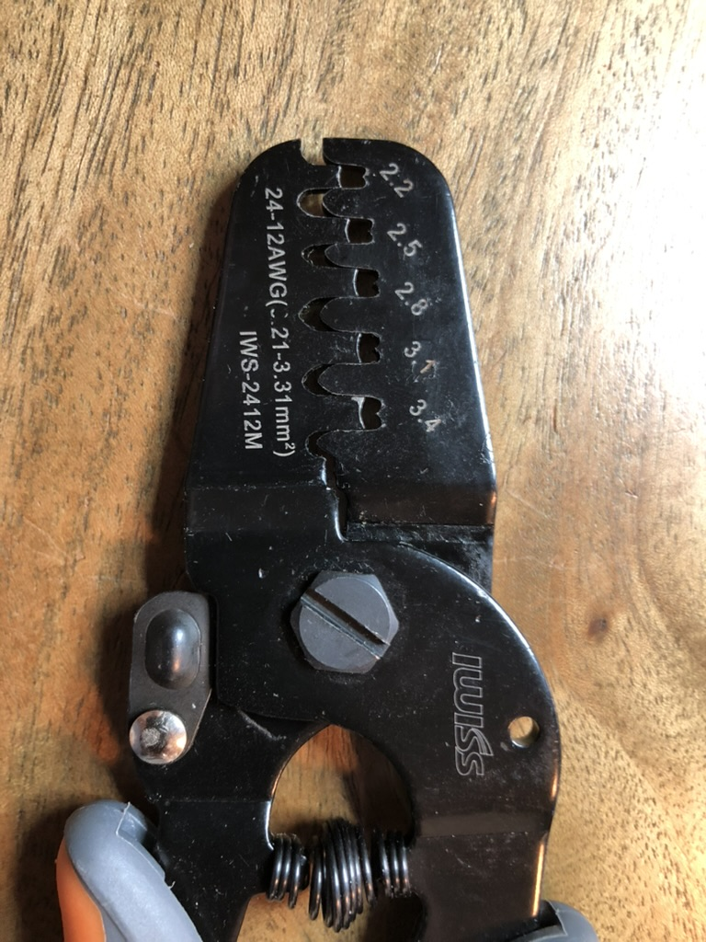

Figure 10. Iwiss IWS-2412M Crimp Tool.

**System Assembly** - Acquire parts per the BOM.

- Populate the three connectors (Items 7 & 8) on the Wireless Link board (Item 6). Install the 24 pin dual row connector first. Next, install one of the single row 8 pin connectors next to the 24 pin connector. Finally install the second 8 pin connector. This installation sequence provides the best access to soldering the pins. Keep them snug and square to the board as shown in Figure 11.

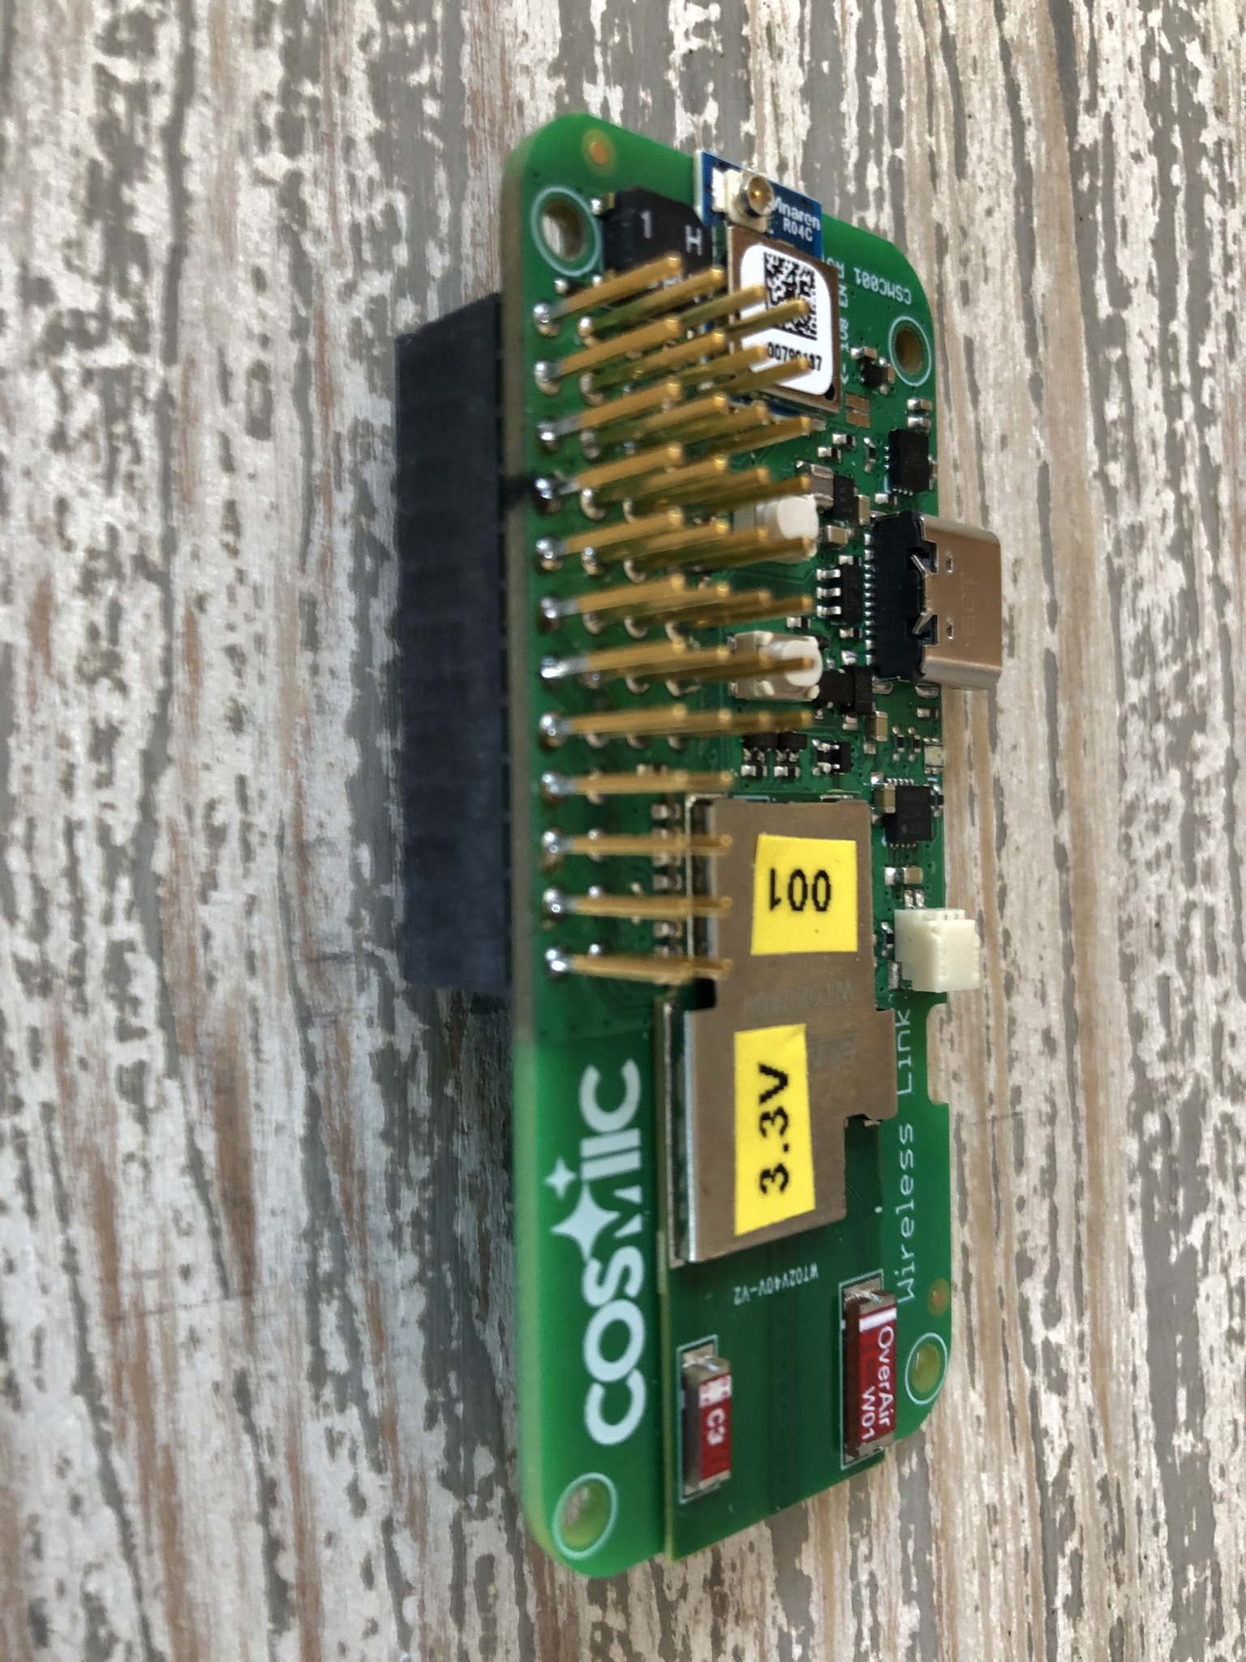

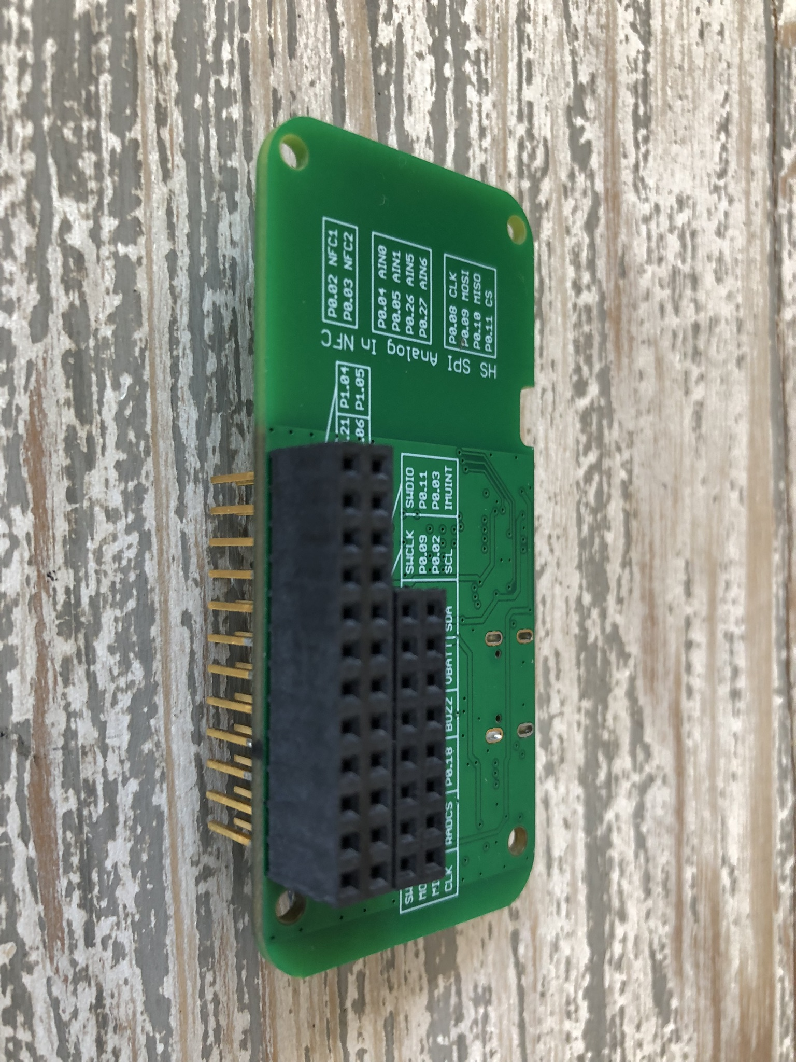

Figure 11. Wireless Link to Main Board Connectors.

- Make sure the 1V8 EN is cut as shown in Figure 12. Measure between the two pads with an ohm meter to make sure the pads are no longer connected.

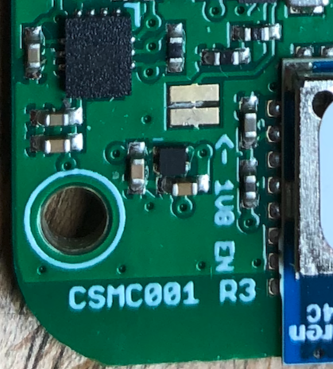

Figure 11. Wireless Link 1V8 Enable Jumper (Yellow Oval).

- Attach the four nylon standoffs (Item 19) to the Main board Wireless Link footprint (WL1) using four nylon 2-56 screws (Item 20).

- Temporarily attach the motherboard to the LED mounting fixture modified enclosure.

-

-

- Attach the motherboard to the enclosure with four 4-40 x 3/16 panhead screws. Pay attention to the orientation in the enclosure. The notched edge of the PCB goes towards the milled edge of the enclosure bottom.

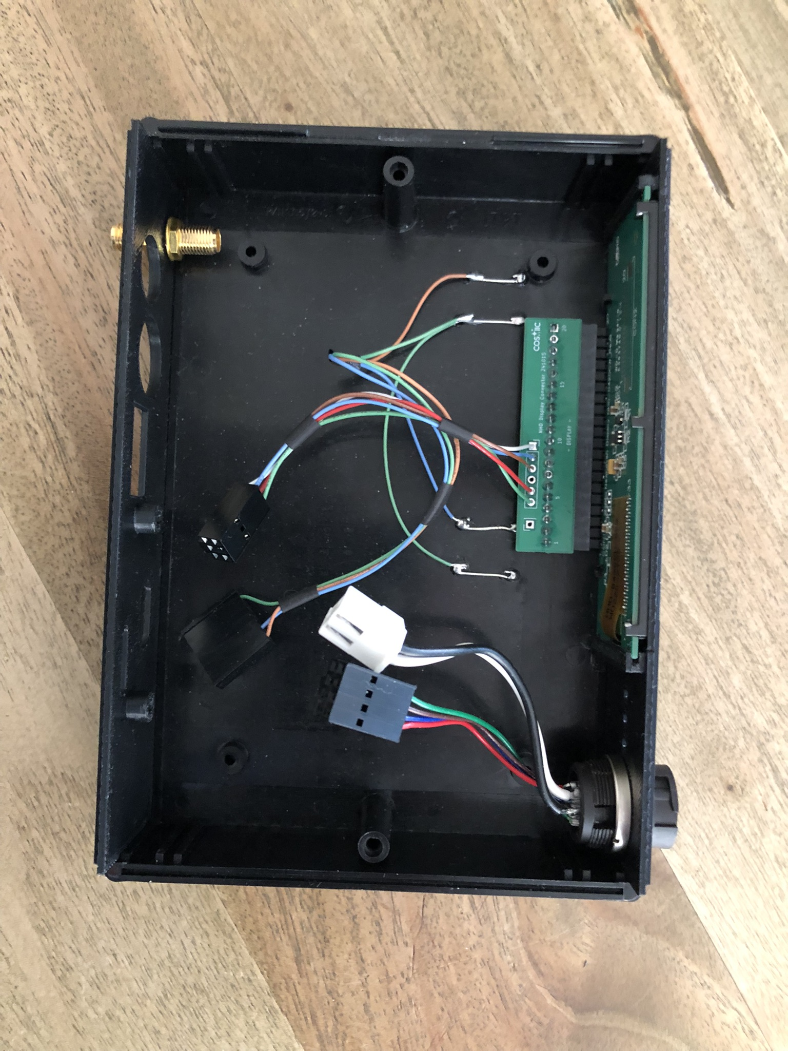

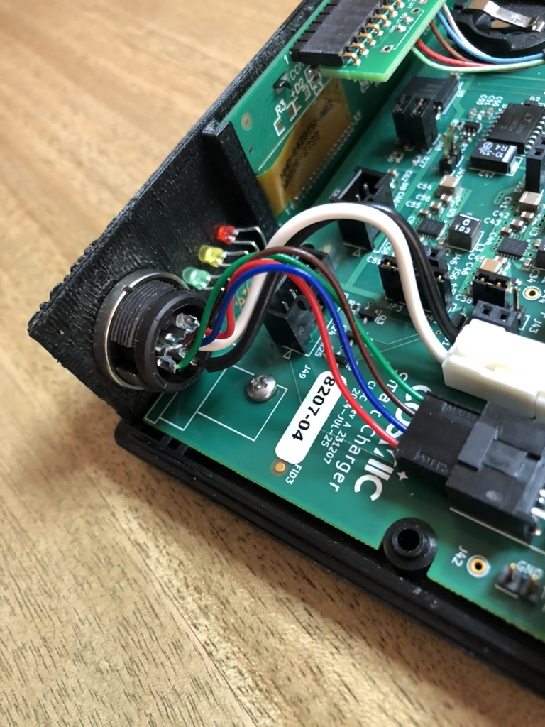

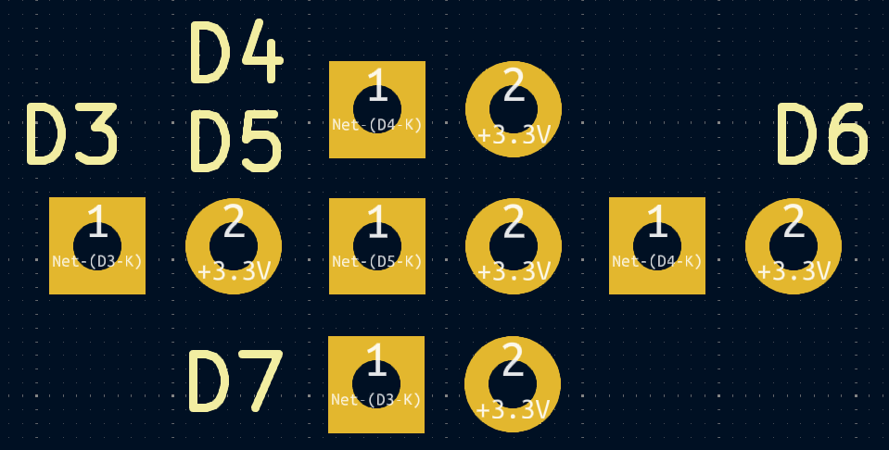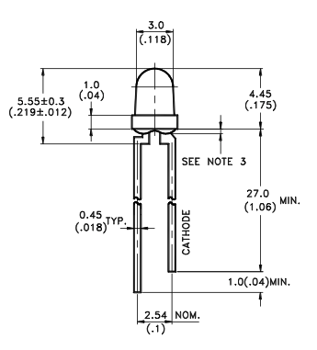

Cathode Anode Cathode Anode Cathode Anode

RED YEL GRN

Figure x. Enclosure LEDs.

